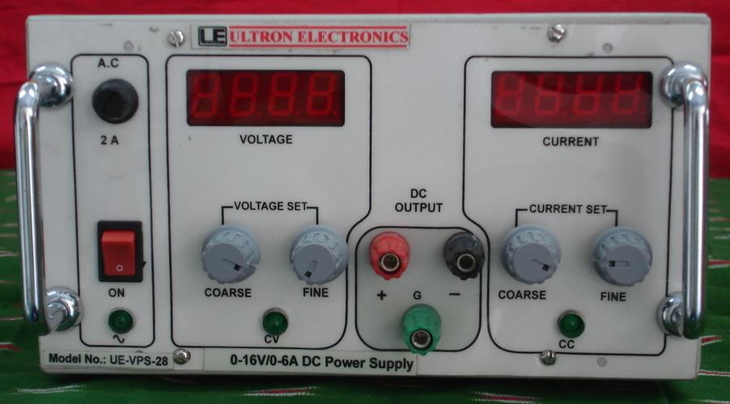

SPECIFICATIONS FOR 0-16V/0-6A VARIABLE DC POWER SUPPLY

1. | Model no |  | : UE-VPS-28.
2. | Mains input |  | : 230V, +10%, 50Hz, Single phase.
3. | Type |  | : CV/CC.
4. | Output | a) Voltage | : | 0-16V Variable continuously with coarse & fine
 |  |  |  | potentiometer mounted on front panel.
 |  | b) Current | : | 0-6A Variable continuously with coarse & fine
 |  |  |  | potentiometer mounted on front panel.
5. | Line Regulation |  | : + 0.1% max. Output Voltage for + 10% change
 |  |  |  | in mains Input Voltage.
6. | Load Regulation |  | : + 0.1% max. Output Voltage Change for No-load
 |  |  |  | to full load or Vice-versa.
7. | Ripple |  | : Less than 2mV R.M.S.
8. | Protections |  | : a) Unit is protected by input fuse,
 |  |  |  | b) Unit is protected against input surges,
 |  |  |  | c) Output is protected against over loads &
 |  |  |  | Continuous short circuits.

9. Indication(s) : a) One LED for input,

- One LED each for CV and CC indication ,
- One 3½ digit digital panel meter is provided to read output voltage,

- One 3½ digit digital panel meter is provided to read output current.

10. | Controls | : a) One ON/OFF switch to ON/OFF the Unit,
 |  | b) One Core and one fine potentiometer to
 |  | Control the output voltage from 0 to 16V,
 |  | c) One Core and one fine potentiometer to
 |  | Control the output current from 0 to 6A,
 | NOTE | : d) One potentiometer with locknut is
 |  | Provided for over voltage setting if required.
11. | Mechanical | : Bench top / 19” Rack Mounting as required by
 |  | you.
12. | Cooling | : Forced air cooling.
13. | Operating Environment | : 1) 0°C to +50°C
14. | Terminals | : Banana socket(s) at front panel & Piri Terminal
 |  | Strip with remote sensing at rear panel if
 |  | Required.

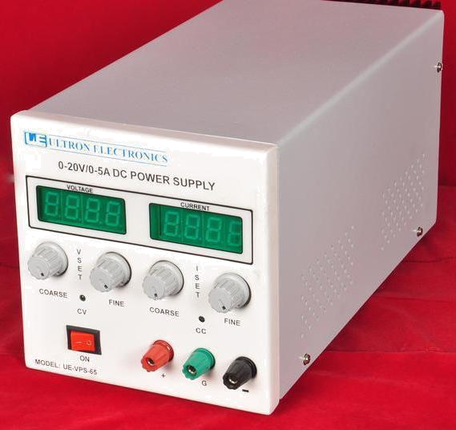

SPECIFICATIONS FOR 0-20V/0-5A VARIABLE DC POWER SUPPLY

1. | Model no |  | : UE-VPS-65.
2. | Mains input |  | : 230V, +10%, 50Hz, Single phase.
3. | Type |  | : CV/CC.
4. | Output | a) Voltage | : | 0-20V Variable continuously with coarse & fine
 |  |  |  | potentiometer mounted on front panel.
 |  | b) Current | : | 0-5A Variable continuously with coarse & fine
 |  |  |  | potentiometer mounted on front panel.
5. | Line Regulation |  | : + 0.1% max. Output Voltage for + 10% change
 |  |  |  | in mains Input Voltage.
6. | Load Regulation |  | : + 0.1% max. Output Voltage Change for No-load
 |  |  |  | to full load or Vice-versa.
7. | Ripple |  | : Less than 2mV R.M.S.
8. | Protections |  | : a) Unit is protected by input fuse,
 |  |  |  | b) Unit is protected against input surges,

c) Output is protected against over loads & Continuous short circuits.

9. | Indication(s) | : | a) One LED for input,
 |  |  | b) One LED each for CV and CC indication,
 |  |  | c) One 3½ digit digital panel meter is provided
 |  |  | to read output voltage,
 |  |  | d) One 3½ digit digital panel meter is provided
 |  |  | to read output current.
10. | Controls | : | a) One ON/OFF switch to ON/OFF the Unit,
 |  |  | b) One Core and one fine potentiometer to
 |  |  | Control the output voltage from 0 to 20V,
 |  |  | c) One Core and one fine potentiometer to
 |  |  | Control the output current from 0 to 5A,
 | NOTE : |  | d) One potentiometer with locknut is
 |  |  | Provided for over voltage setting if required.
11. | Mechanical | : | Bench top / 19” Rack Mounting as required by
 |  |  | you.
12. | Cooling | : | Natural air cooling.
13. | Operating Environment | : | 1) 0°C to +50°C
14. | Terminals | : | Banana socket(s) at front panel & Piri Terminal
 |  |  | Strip with remote sensing at rear panel if
 |  |  | Required.

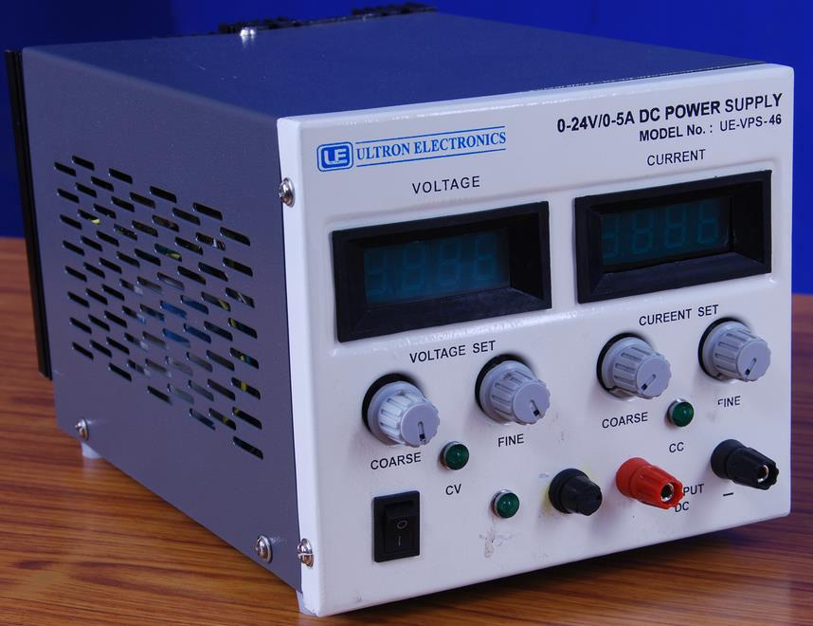

SPECIFICATIONS FOR 0-24V/0-5A VARIABLE DC POWER SUPPLY

1. | Model no |  | : UE-VPS-46.
2. | Mains input |  | : 230V, +10%, 50Hz, Single phase.
3. | Type |  | : CV/CC.
4. | Output | a) Voltage | : | 0-24V Variable continuously with coarse & fine
 |  |  |  | potentiometer mounted on front panel.
 |  | b) Current | : | 0-5A Variable continuously with coarse & fine
 |  |  |  | potentiometer mounted on front panel.
5. | Line Regulation |  | : + 0.1% max. Output Voltage for + 10% change
 |  |  |  | in mains Input Voltage.
6. | Load Regulation |  | : + 0.1% max. Output Voltage Change for No-load
 |  |  |  | to full load or Vice-versa.
7. | Ripple |  | : Less than 2mV R.M.S.
8. | Protections |  | : a) Unit is protected by input fuse,
 |  |  |  | b) Unit is protected against input surges,

c) Output is protected against over loads & Continuous short circuits.

9. Indication(s) : a) One LED for input,
- One LED each for CV and CC indication ,

- One 3½ digit digital panel meter is provided to read output voltage,

- One 3½ digit digital panel meter is provided to read output current.
10. | Controls | : | a) One ON/OFF switch to ON/OFF the Unit,
 |  |  | b) One Core and one fine potentiometer to
 |  |  | Control the output voltage from 0 to 24V,
 |  |  | c) One Core and one fine potentiometer to
 |  |  | Control the output current from 0 to 5A,
 | NOTE : |  | d) One potentiometer with locknut is
 |  |  | Provided for over voltage setting if required.
11. | Mechanical | : | Bench top / 19” Rack Mounting as required by
 |  |  | you.
12. | Cooling | : | Natural air cooling.
13. | Operating Environment | : | 1) 0°C to +50°C
14. | Terminals | : | Banana socket(s) at front panel & Piri Terminal
 |  |  | Strip with remote sensing at rear panel if
 |  |  | Required.

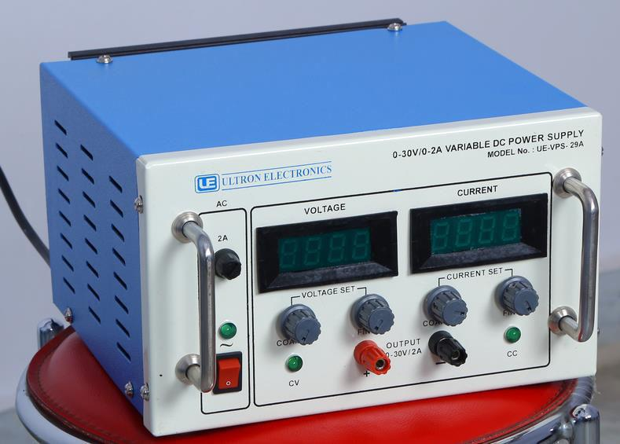

SPECIFICATIONS FOR 0-30V/0-2A VARIABLE DC POWER SUPPLY

1. | Model no |  | : UE-VPS-29A.
2. | Mains input |  | : 230V, +10%, 50Hz, Single phase.
3. | Type |  | : CV/CC.
4. | Output | a) Voltage | : | 0-30V Variable continuously with coarse & fine
 |  |  |  | potentiometer mounted on front panel.
 |  | b) Current | : | 0-2A Variable continuously with coarse & fine
 |  |  |  | potentiometer mounted on front panel.
5. | Line Regulation |  | : + 0.1% max. Output Voltage for + 10% change
 |  |  |  | in mains Input Voltage.
6. | Load Regulation |  | : + 0.1% max. Output Voltage Change for No-load
 |  |  |  | to full load or Vice-versa.
7. | Ripple |  | : Less than 2mV R.M.S.
8. | Protections |  | : a) Unit is protected by input fuse,
 |  |  |  | b) Unit is protected against input surges,

c) Output is protected against over loads & Continuous short circuits.

9. Indication(s) : a) One LED for input,
- One LED each for CV and CC indication ,

- One 3½ digit digital panel meter is provided to read output voltage,

- One 3½ digit digital panel meter is provided to read output current.

10. | Controls | : a) One ON/OFF switch to ON/OFF the Unit,
 |  | b) One Core and one fine potentiometer to
 |  | Control the output voltage from 0 to 30V,
 |  | c) One Core and one fine potentiometer to
 |  | Control the output current from 0 to 2A,
 | NOTE | : d) One potentiometer with locknut is
 |  | Provided for over voltage setting if required.
11. | Mechanical | : Bench top / 19” Rack Mounting as required by
 |  | you.
12. | Cooling | : Natural air cooling.
13. | Operating Environment | : 1) 0°C to +50°C
14. | Terminals | : Banana socket(s) at front panel & Piri Terminal
 |  | Strip with remote sensing at rear panel if
 |  | Required.

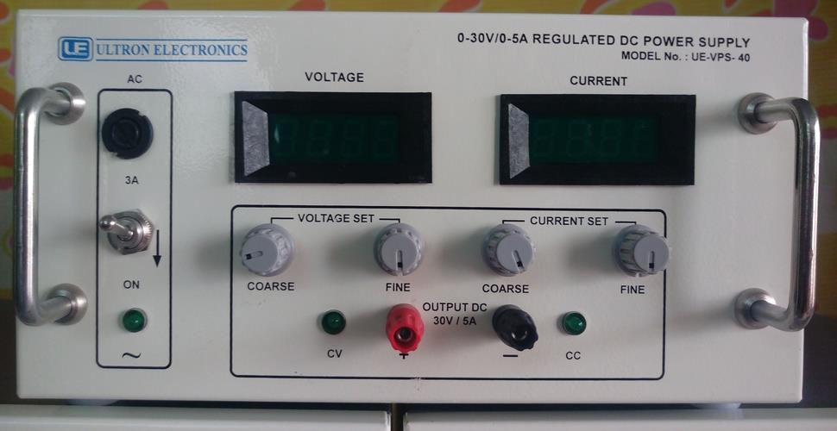

SPECIFICATIONS FOR 0-30V/0-5A REGULATED DC POWER SUPPLY

1. | Model no |  | : UE-VPS-40.
2. | Mains input |  | : 230V, +10%, 50Hz, Single phase.
3. | Type |  | : CV/CC.
4. | Output | a) Voltage | : | 0-30V Variable continuously with coarse & fine
 |  |  |  | potentiometer mounted on front panel.
 |  | b) Current | : | 0-5A Variable continuously with coarse & fine
 |  |  |  | potentiometer mounted on front panel.
5. | Line Regulation |  | : + 0.1% max. Output Voltage for + 10% change
 |  |  |  | in mains Input Voltage.
6. | Load Regulation |  | : + 0.1% max. Output Voltage Change for No-load
 |  |  |  | to full load or Vice-versa.
7. | Ripple |  | : Less than 2mV R.M.S.
8. | Protections |  | : a) Unit is protected by input fuse,
 |  |  |  | b) Unit is protected against input surges,

c) Output is protected against over loads & Continuous short circuits.

9. Indication(s) : a) One LED for input,
- One LED each for CV and CC indication ,

- One 3½ digit digital panel meter is provided to read output voltage,

- One 3½ digit digital panel meter is provided to read output current.

10. | Controls | : | a) One ON/OFF switch to ON/OFF the Unit,
 |  |  | b) One Core and one fine potentiometer to
 |  |  | Control the output voltage from 0 to 30V,
 |  |  | c) One Core and one fine potentiometer to
 |  |  | Control the output current from 0 to 5A,
 | NOTE : |  | d) One potentiometer with locknut is
 |  |  | Provided for over voltage setting if required.
11. | Mechanical | : | Bench top / 19” Rack Mounting as required by
 |  |  | you.
12. | Cooling | : | Natural air cooling.
13. | Operating Environment | : | 1) 0°C to +50°C
14. | Terminals | : | Banana socket(s) at front panel & Piri Terminal
 |  |  | Strip with remote sensing at rear panel if
 |  |  | Required.

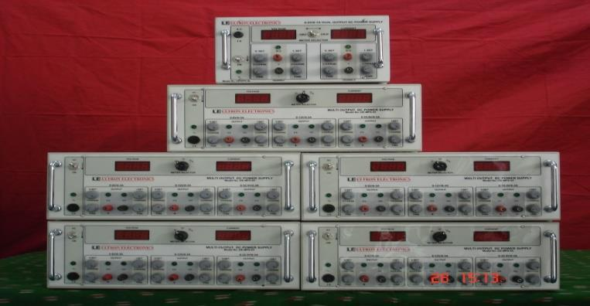

SPECIFICATIONS FOR 0-30V/0-10A VARIABLE DC POWER SUPPLY

1. | Model no |  | : UE-VPS-3010.
2. | Mains input |  | : 230V, +10%, 50Hz, Single phase.
3. | Type |  | : CV/CC.
4. | Output | a) Voltage | : | 0-30V Variable continuously with coarse & fine
 |  |  |  | potentiometer mounted on front panel.
 |  | b) Current | : | 0-10A Variable continuously with coarse & fine
 |  |  |  | potentiometer mounted on front panel.
5. | Line Regulation |  | : + 0.1% max. Output Voltage for + 10% change
 |  |  |  | in mains Input Voltage.
6. | Load Regulation |  | : + 0.1% max. Output Voltage Change for No-load
 |  |  |  | to full load or Vice-versa.
7. | Ripple |  | : Less than 2mV R.M.S.
8. | Protections |  | : a) Unit is protected by input fuse,
 |  |  |  | b) Unit is protected against input surges,
 |  |  |  | c) Output is protected against over loads &
 |  |  |  | Continuous short circuits.

9. Indication(s) : a) One LED for input,

- One LED each for CV and CC indication ,

- One 3½ digit digital panel meter is provided to read output voltage,

- One 3½ digit digital panel meter is provided to read output current.

10. Controls : a) One ON/OFF switch to ON/OFF the Unit,

- One Core and one fine potentiometer to Control the output voltage from 0 to 30V,

- One Core and one fine potentiometer to Control the output current from 0 to 10A,

NOTE : d) One potentiometer with locknut is
Provided for over voltage setting if required.

11. | Mechanical | : Bench top / 19” Rack Mounting as required by
 |  | you.
12. | Cooling | : Forced air cooling.
13. | Operating Environment | : 1) 0°C to +50°C
14. | Terminals | : Banana socket(s) at front panel & Piri Terminal
 |  | Strip with remote sensing at rear panel if
 |  | Required.

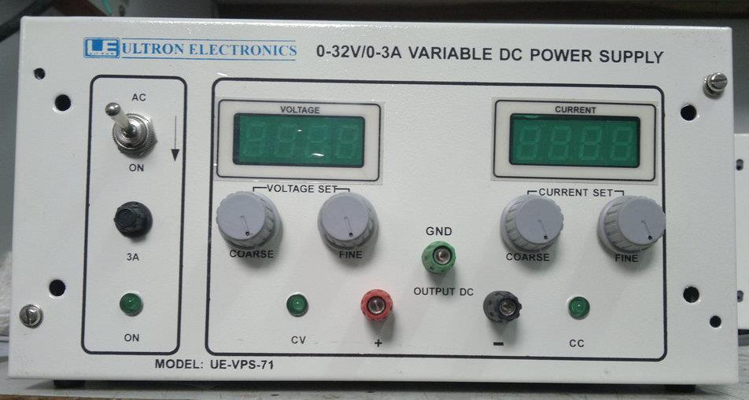

SPECIFICATIONS FOR 0-32V/0-3A VARIABLE DC POWER SUPPLY

1. | Model no |  | : UE-VPS-71.
2. | Mains input |  | : 230V, +10%, 50Hz, Single phase.
3. | Type |  | : CV/CC.
4. | Output | a) Voltage | : | 0-32V Variable continuously with coarse & fine
 |  |  |  | potentiometer mounted on front panel.
 |  | b) Current | : | 0-3A Variable continuously with coarse & fine
 |  |  |  | potentiometer mounted on front panel.
5. | Line Regulation |  | : + 0.1% max. Output Voltage for + 10% change
 |  |  |  | in mains Input Voltage.
6. | Load Regulation |  | : + 0.1% max. Output Voltage Change for No-load
 |  |  |  | to full load or Vice-versa.
7. | Ripple |  | : Less than 2mV R.M.S.
8. | Protections |  | : a) Unit is protected by input fuse,
 |  |  |  | b) Unit is protected against input surges,

c) Output is protected against over loads & Continuous short circuits.

9. Indication(s) : a) One LED for input,

- One LED each for CV and CC indication ,

- One 3½ digit digital panel meter is provided to read output voltage,

- One 3½ digit digital panel meter is provided to read output current.

10. | Controls | : a) One ON/OFF switch to ON/OFF the Unit,
 |  |  | b) One Core and one fine potentiometer to
 |  |  | Control the output voltage from 0 to 32V,
 |  |  | c) One Core and one fine potentiometer to
 |  |  | Control the output current from 0 to 3A,
 | NOTE : |  | d) One potentiometer with locknut is
 |  |  | Provided for over voltage setting if required.
11. | Mechanical | : Bench top / 19” Rack Mounting as required by
 |  |  | you.
12. | Cooling | : | Natural air cooling.
13. | Operating Environment | : 1) 0°C to +50°C
14. | Terminals | : Banana socket(s) at front panel & Piri Terminal
 |  |  | Strip with remote sensing at rear panel if
 |  |  | Required.

SPECIFICATIONS FOR 0-32V/0-10A VARIABLE DC POWER SUPPLY

1. | Model no |  | : UE-VPS-3010.
2. | Mains input |  | : 230V, +10%, 50Hz, Single phase.
3. | Type |  | : CV/CC.
4. | Output | a) Voltage | : | 0-32V Variable continuously with coarse & fine
 |  |  |  | potentiometer mounted on front panel.
 |  | b) Current | : | 0-10A Variable continuously with coarse & fine
 |  |  |  | potentiometer mounted on front panel.
5. | Line Regulation |  | : + 0.1% max. Output Voltage for + 10% change
 |  |  |  | in mains Input Voltage.
6. | Load Regulation |  | : + 0.1% max. Output Voltage Change for No-load
 |  |  |  | to full load or Vice-versa.
7. | Ripple |  | : Less than 2mV R.M.S.
8. | Protections |  | : a) Unit is protected by input fuse,
 |  |  |  | b) Unit is protected against input surges,
 |  |  |  | c) Output is protected against over loads &
 |  |  |  | Continuous short circuits.

9. Indication(s) : a) One LED for input,

- One LED each for ON CV and CC indication ,

- One 3½ digit digital panel meter is provided to read output voltage,

- One 3½ digit digital panel meter is provided to read output current.

10. Controls : a) One ON/OFF switch to ON/OFF the Unit,

- One Core and one fine potentiometer to Control the output voltage from 0 to 32V,

- One Core and one fine potentiometer to Control the output current from 0 to 10A,

NOTE : d) One potentiometer with locknut is
Provided for over voltage setting if required.

11. | Mechanical | : Bench top / 19” Rack Mounting as required by
 |  | you.
12. | Cooling | : Forced air cooling.
13. | Operating Environment | : 1) 0°C to +50°C
14. | Terminals | : Banana socket(s) at front panel & Piri Terminal
 |  | Strip with remote sensing at rear panel if
 |  | Required.

SPECIFICATIONS FOR 0-48V/0-10A VARIABLE DC POWER SUPPLY

1. | Model no |  | : UE-VPS-62B.
2. | Mains input |  | : 230V, +10%, 50Hz, Single phase.
3. | Type |  | : CV/CC.
4. | Output | a) Voltage | : | 0-48V Variable continuously with coarse & fine
 |  |  |  | potentiometer mounted on front panel.
 |  | b) Current | : | 0-10A Variable continuously with coarse & fine
 |  |  |  | potentiometer mounted on front panel.
5. | Line Regulation |  | : + 0.1% max. Output Voltage for + 10% change
 |  |  |  | in mains Input Voltage.
6. | Load Regulation |  | : + 0.1% max. Output Voltage Change for No-load
 |  |  |  | to full load or Vice-versa.
7. | Ripple |  | : Less than 2mV R.M.S.
8. | Protections |  | : a) Unit is protected by input fuse,
 |  |  |  | b) Unit is protected against input surges,
 |  |  |  | c) Output is protected against over loads &
 |  |  |  | Continuous short circuits.

9. Indication(s) : a) One LED for input,

- One LED each for CV and CC indication ,

- One 3½ digit digital panel meter is provided to read output voltage,

- One 3½ digit digital panel meter is provided to read output current.

10. Controls : a) One ON/OFF switch to ON/OFF the Unit,

- One Core and one fine potentiometer to Control the output voltage from 0 to 48V,

- One Core and one fine potentiometer to Control the output current from 0 to 10A,

- NOTE: One potentiometer with locknut is Provided for over voltage setting if required.
11. | Mechanical | : Bench top / 19” Rack Mounting as required by
 |  | you.
12. | Cooling | : Forced air cooling.
13. | Operating Environment | : 1) 0°C to +50°C
14. | Terminals | : Banana socket(s) at front panel & Piri Terminal
 |  | Strip with remote sensing at rear panel if
 |  | Required.

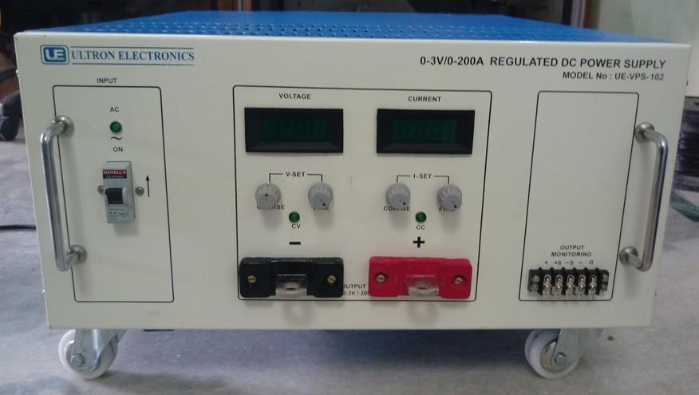

SPECIFICATIONS FOR 0-3V/0-200A REGULATED DC POWER SUPPLY

1. | Model no |  | : UE-VPS-102.
2. | Mains input |  | : 230V, +10%, 50Hz, Single phase.
3. | Type |  | : CV/CC.
4. | Output | a) Voltage | : | 0-3V Variable continuously with coarse & fine
 |  |  |  | potentiometer mounted on front panel.
 |  | b) Current | : | 0-200A Variable continuously with coarse & fine
 |  |  |  | potentiometer mounted on front panel.
5. | Line Regulation |  | : + 0.1% max. Output Voltage for + 10% change
 |  |  |  | in mains Input Voltage.
6. | Load Regulation |  | : + 0.1% max. Output Voltage Change for No-load
 |  |  |  | to full load or Vice-versa.
7. | Ripple |  | : Less than 2mV R.M.S.
8. | Protections |  | : a) Unit is protected by input fuse,
 |  |  |  | b) Unit is protected against input surges,
 |  |  |  | c) Output is protected against over loads &
 |  |  |  | Continuous short circuits.

9. | Indication(s) | : a) One LED for input,
 |  | b) One LED each for CV and CC indication
 |  | c) One 3½ digit digital panel meter is provided
 |  | to read output voltage,
 |  | d) One 3½ digit digital panel meter is provided
 |  | to read output current.
10. | Controls | : a) One ON/OFF switch to ON/OFF the Unit,
 |  | b) One Core and one fine potentiometer to
 |  | Control the output voltage from 0 to 3V,
 |  | c) One Core and one fine potentiometer to
 |  | Control the output current from 0 to 200A,
 | NOTE | : d) One potentiometer with locknut is
 |  | Provided for over voltage setting if required.
11. | Mechanical | : Bench top / 19” Rack Mounting as required by
 |  | you.
12. | Cooling | : Forced air cooling.
13. | Operating Environment | : 1) 0°C to +50°C
14. | Terminals | : Banana socket(s) at front panel & Piri Terminal
 |  | Strip with remote sensing at rear panel if
 |  | Required.

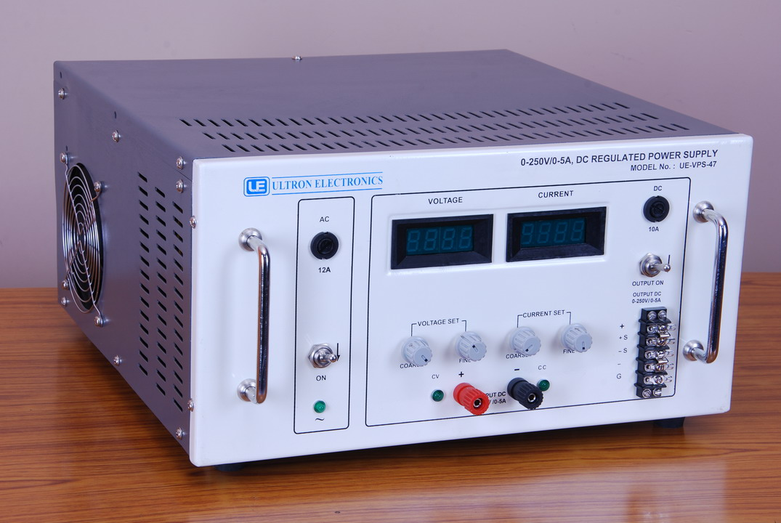
SPECIFICATIONS FOR 0-250V/0-5A REGULATED DC POWER SUPPLY

1. | Model no |  | : UE-VPS-47.
2. | Mains input |  | : 230V, +10%, 50Hz, Single phase.
3. | Type |  | : CV/CC.
4. | Output | a) Voltage | : | 0-250V Variable continuously with coarse & fine
 |  |  |  | potentiometer mounted on front panel.
 |  | b) Current | : | 0-5A Variable continuously with coarse & fine
 |  |  |  | potentiometer mounted on front panel.
5. | Line Regulation |  | : + 0.1% max. Output Voltage for + 10% change
 |  |  |  | in mains Input Voltage.
6. | Load Regulation |  | : + 0.1% max. Output Voltage Change for No-load
 |  |  |  | to full load or Vice-versa.
7. | Ripple |  | : Less than 2mV R.M.S.
8. | Protections |  | : a) Unit is protected by input fuse,
 |  |  |  | b) Unit is protected against input surges,
 |  |  |  | c) Output is protected against over loads &
 |  |  |  | Continuous short circuits.

9. | Indication(s) | : a) One LED for input,
 |  | b) One LED each for CV and CC indication,
 |  | c) One 3½ digit digital panel meter is provided
 |  | to read output voltage,
 |  | d) One 3½ digit digital panel meter is provided
 |  | to read output current.
10. | Controls | : a) One ON/OFF switch to ON/OFF the Unit,
 |  | b) One Core and one fine potentiometer to
 |  | Control the output voltage from 0 to 250V,
 |  | c) One Core and one fine potentiometer to
 |  | Control the output current from 0 to 5A,
 | NOTE | : d) One potentiometer with locknut is
 |  | Provided for over voltage setting if required.
11. | Mechanical | : Bench top / 19” Rack Mounting as required by
 |  | you.
12. | Cooling | : Forced air cooling.
13. | Operating Environment | : 1) 0°C to +50°C
14. | Terminals | : Banana socket(s) at front panel & Piri Terminal
 |  | Strip with remote sensing at rear panel if
 |  | Required.

